IMPLEMENT CLIENT SCRIPT & UI POLICY (INCIDENT)

1. PROJECT TITLE
Implement Client Script & UI Policy (Incident)
The project “Implement Client Script & UI Policy (Incident)” is developed using the ServiceNow Incident Management application.
The project focuses on implementing UI Policies, UI Policy Actions, and Client Scripts to control and validate the behaviour of Incident records.
The implemented configuration provides dynamic field control based on Incident Impact, automatic field value updates, submission validation, and restrictions on unwanted State changes through direct list editing.

2. PROJECT OVERVIEW
ServiceNow provides Incident Management functionality for recording, managing, and resolving incidents within an organization. Incident records contain important information such as Impact, Urgency, Assignment Group, Assigned To, and State.
The project demonstrates how ServiceNow configuration features can be used to improve the behaviour of the Incident form without changing the overall Incident Management process.
The project implements a combination of:
- UI Policy
- UI Policy Action
- onChange Client Script
- onSubmit Client Script
- onCellEdit Client Script
The main UI Policy is named High Impact Control. It is applied when the Incident Impact is set to 1 – High.
When the condition is satisfied, the configuration makes Assignment Group mandatory and controls the Urgency field.
The onChange Client Script automatically sets Urgency to High when Impact becomes High.
The onSubmit Client Script validates the Incident before submission and prevents the record from being submitted when a High Impact Incident does not have an Assigned To value.
The onCellEdit Client Script controls State changes made directly from the Incident list and prevents unwanted list-based State modifications.
The project was implemented and tested in the ServiceNow Incident Management environment.

3. PROBLEM STATEMENT
Incident records may require different field behaviours depending on the information entered by the user.
For example, a High Impact Incident may require an Assignment Group to be specified before the record can be properly processed. Similarly, certain field values may need to be automatically updated based on the Incident Impact.
Without appropriate configuration, users may:
- Leave important fields incomplete.
- Enter inconsistent Incident information.
- Submit a High Impact Incident without an Assigned To value.
- Make unwanted State changes directly from the Incident list.
- Manually update values that could be automatically controlled.
These situations can affect the consistency and correctness of Incident records.
Therefore, the project implements ServiceNow UI Policies and Client Scripts to introduce dynamic field control, automatic value updates, submission validation, and list-edit restrictions.
The purpose is to improve the controlled behaviour of the Incident form and ensure that the required conditions are followed when working with Incident records.

4. USER STORY
4.1 User Story
As a ServiceNow user, I want the Incident form to automatically control fields based on the Incident Impact and validate important information, so that Incidents can be submitted correctly and unwanted list-based changes can be prevented.
4.2 User Requirements
The user should be able to:
- Create or open an Incident.
- Set the Incident Impact.
- Observe dynamic field behaviour.
- Enter the required Assignment Group.
- Have Urgency automatically controlled when Impact is High.
- Receive validation when required Assigned To information is missing.
- Submit a valid Incident successfully.
- Update State through the Incident form.
- Be prevented from making unwanted State changes through direct list editing.

5. OBJECTIVES
The main objectives of the project are:
5.1 Dynamic Incident Field Control
To implement a UI Policy that changes the behaviour of Incident fields based on the Impact value.
5.2 Mandatory Assignment Group
To make the Assignment Group field mandatory when Impact is set to 1 – High.
5.3 Urgency Field Control
To make the Urgency field read-only when the High Impact condition is active.
5.4 Automatic Urgency Update
To automatically set Urgency to High when the Impact field is changed to High.
5.5 Incident Submission Validation
To prevent submission of a High Impact Incident when the Assigned To field is empty.
5.6 State List-Edit Control
To prevent direct State changes through Incident list editing.
5.7 Form-Based State Update
To allow valid State changes to be performed through the Incident form.
5.8 Configuration Testing
To test the implemented configuration under different Incident conditions and verify that the expected behaviour occurs.

6. REQUIREMENTS
6.1 Functional Requirements
ID | Requirement
FR-01 | The system must provide an Incident form.
FR-02 | A UI Policy must be activated when Impact is High.
FR-03 | Assignment Group must become mandatory when Impact is High.
FR-04 | Urgency must become read-only when Impact is High.
FR-05 | Urgency must automatically be set to High when Impact changes to High.
FR-06 | A High Impact Incident must not be submitted when Assigned To is empty.
FR-07 | Direct State changes through Incident list editing must be prevented.
FR-08 | State changes through the Incident form must be allowed.
6.2 Non-Functional Requirements
The project also has the following non-functional requirements:
- The configuration should be simple for users to understand.
- The implemented Client Scripts should respond correctly to user actions.
- The configuration should maintain consistent Incident information.
- The configuration should be testable within the ServiceNow Incident Management environment.
- The implemented behaviour should be consistent with the configured conditions.
- The configuration should provide appropriate feedback when an action is prevented.
6.3 ServiceNow Requirements
The project requires:
- A ServiceNow instance.
- Incident Management functionality.
- Access to the Incident application.
- Permission to create and configure UI Policies.
- Permission to create and configure Client Scripts.
- Access to Incident records and list views.
- A modern web browser.

7. SYSTEM DESIGN
7.1 Overall Design
The project follows a condition-based Incident management design.
The main logical flow is:
Incident Form → Impact = High → UI Policy Activation → Field Control → Client Script Execution → Validation → Incident Update
The State control process follows two separate paths.
List-Based State Change
Incident List → State Edit → onCellEdit Client Script → Warning → Change Blocked
Form-Based State Change
Incident Form → State Update → Valid Form Submission → Update Successful

7.2 Main Components
The project consists of the following ServiceNow components:
UI Policy
Name: High Impact Control
The UI Policy controls field behaviour when Impact is 1 – High.
UI Policy Action
The UI Policy Action controls the Urgency field and makes it read-only when the UI Policy condition is satisfied.
onChange Client Script
Name: Auto set urgency for high impact
The script responds to changes in the Impact field.
onSubmit Client Script
Name: Prevent save if Assigned To missing
The script validates the Incident before submission.
onCellEdit Client Script
Name: Prevent state change via list edit
The script controls State changes made directly from the Incident list.

7.3 Design Behaviour
When Impact is set to High:
- The High Impact Control UI Policy becomes active.
- Assignment Group becomes mandatory.
- Urgency becomes read-only.
- The onChange Client Script automatically sets Urgency to High.
- During submission, the onSubmit Client Script checks Assigned To.
- If Assigned To is empty, submission is prevented.
- If the required information is provided, the Incident can be saved.
For State changes:
- Direct list editing is blocked by the onCellEdit Client Script.
- State can still be changed through the Incident form.

8. IMPLEMENTATION
8.1 UI Policy Implementation
A UI Policy named High Impact Control was created for the Incident table.
Configuration
- Name: High Impact Control
- Table: Incident
- Active: Yes
- Condition: Impact is 1 – High
- Reverse if false: Yes
The UI Policy makes Assignment Group mandatory when the condition is satisfied.
When Impact changes from High to another value, the configured behaviour is reversed because Reverse if false is enabled.

8.2 UI Policy Action Implementation
A UI Policy Action was created under the High Impact Control UI Policy.
Configuration
- Field: Urgency
- Read-only: Yes
- Visible: Unchanged
- Mandatory: Left unchanged
When Impact is High, the Urgency field becomes read-only.

8.3 onChange Client Script Implementation
Client Script Name
Auto set urgency for high impact
Configuration
- Table: Incident
- Type: onChange
- Field: Impact
- Active: Yes
Function
The script executes when the Impact field changes.
When Impact becomes 1 – High, the script:
- Detects the High Impact value.
- Sets the Urgency value to High.
- Displays an informational message to the user.
This provides automatic field behaviour without requiring the user to manually select the corresponding Urgency value.
8.4 onSubmit Client Script Implementation
Client Script Name
Prevent save if Assigned To missing
Configuration
- Table: Incident
- Type: onSubmit
- Active: Yes
Function
The script checks two conditions:
- Impact is High.
- Assigned To is empty.
If both conditions are satisfied, the submission is prevented and an error message is displayed.
If a valid Assigned To value is provided, the Incident can be submitted normally.
This provides validation before the Incident record is saved.
8.5 onCellEdit Client Script Implementation
Client Script Name
Prevent state change via list edit
Configuration
- Table: Incident
- Type: onCellEdit
- Field: State
- Active: Yes
Function
The script executes when a user attempts to change the State directly from the Incident list.
The script:
- Detects the list-based State change.
- Displays a warning message.
- Prevents the State change.
Users can instead open the Incident record and update State through the Incident form.
8.6 Configuration Verification
After implementation, the following configuration items were verified:
- High Impact Control UI Policy is active.
- Impact condition is set to 1 – High.
- Reverse if false is enabled.
- Assignment Group is configured as mandatory.
- Urgency UI Policy Action is configured as read-only.
- onChange Client Script is associated with Impact.
- onSubmit Client Script is active.
- onCellEdit Client Script is associated with State.
- Configuration names are consistent with the project documentation.

9. TESTING
The implemented configuration was tested using five main test cases.
9.1 Test Case 1 – High Impact Mandatory Enforcement
Objective
To verify that the required field behaviour is activated when Impact is High.
Test Procedure
- Open an Incident record.
- Set Impact to 1 – High.
- Observe the Assignment Group field.
- Leave the required information incomplete where applicable.
- Attempt to submit the Incident.
Expected Result
The Assignment Group should become mandatory and the appropriate validation should be applied.

9.2 Test Case 2 – Successful Incident Save
Objective
To verify that a valid High Impact Incident can be saved when the required information is provided.
Test Procedure
- Open an Incident.
- Set Impact to 1 – High.
- Provide a valid Assigned To user.
- Provide the required Incident information.
- Submit the Incident.
Expected Result
The Incident should be saved successfully.

9.3 Test Case 3 – Reverse Condition
Objective
To verify that the UI Policy behaviour is reversed when the Impact condition becomes false.
Test Procedure
- Open an Incident.
- Set Impact to 1 – High.
- Observe the configured field behaviour.
- Change Impact from High to Medium.
- Observe the fields again.
Expected Result
The UI Policy behaviour should be reversed and the applicable fields should return to their normal state.

9.4 Test Case 4 – State List-Edit Blocking
Objective
To verify that direct State changes through Incident list editing are prevented.
Test Procedure
- Open the Incident list.
- Locate an Incident.
- Attempt to change its State directly from the list.
- Observe the message displayed by the Client Script.
Expected Result
A warning should be displayed and the list-based State change should be prevented.

9.5 Test Case 5 – Form-Based State Update
Objective
To verify that State can still be changed through the Incident form.
Test Procedure
- Open an Incident record.
- Open the Incident form.
- Change the State.
- Save or update the record.
- Verify the resulting State.
Expected Result
The State change should be accepted and saved successfully.

9.6 Testing Result
The five tests cover:
- Mandatory field enforcement.
- Successful Incident submission.
- Reverse UI Policy behaviour.
- State list-edit blocking.
- Form-based State updating.
These tests provide functional verification of the implemented UI Policy, UI Policy Action, and Client Scripts.

10. DEMONSTRATION
The project can be demonstrated directly from the ServiceNow Incident Management environment.
10.1 Incident Form Demonstration
- Open the ServiceNow instance.
- Navigate to the Incident application.
- Open an Incident record.
- Set Impact to 1 – High.
- Show that Assignment Group becomes mandatory.
- Show the Urgency field behaviour.
- Demonstrate the automatic Urgency update.

10.2 Submission Validation Demonstration
- Keep Impact as High.
- Leave Assigned To empty.
- Attempt to submit the Incident.
- Show the validation/error message.
- Assign a valid user.
- Submit the Incident.
- Show that the Incident is saved successfully.

10.3 State List-Edit Demonstration
- Open the Incident list.
- Attempt to change State directly from the list.
- Show the warning message.
- Show that the change is blocked.

10.4 Form-Based State Demonstration
- Open the Incident record.
- Change State through the Incident form.
- Update the record.
- Show that the State change is accepted.

10.5 Demonstration Flow
The complete demonstration can be summarized as:
Incident → Impact High → UI Policy → Field Control → Client Script → Validation → Successful Update
For list editing:
Incident List → State Edit → onCellEdit → Warning → Change Blocked
For normal form editing:
Incident Form → State Update → Submit → Update Successful

11. EVIDENCE / SCREENSHOTS
The project is supported by screenshots captured from the ServiceNow environment.
The screenshots provide evidence of both the configuration and the functional testing.
11.1 UI Policy Evidence
Figure 11.1 – High Impact Control UI Policy
The screenshot shows:
- UI Policy name.
- Incident table.
- Active status.
- Impact = 1 – High condition.
- Reverse if false configuration.
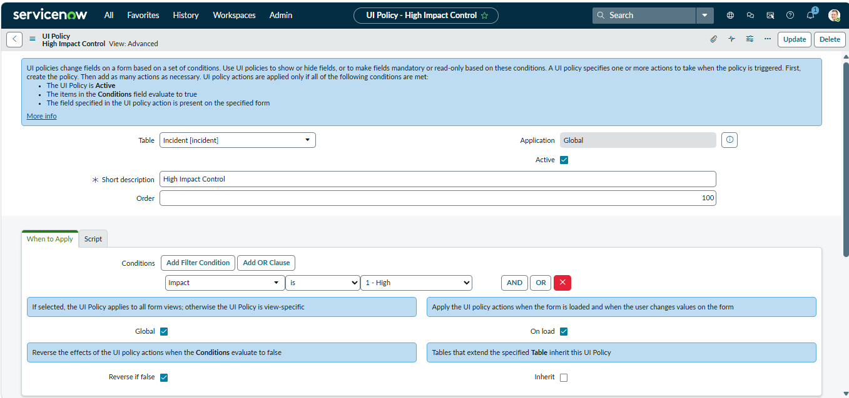
11.2 UI Policy Action Evidence
Figure 11.2 – Urgency UI Policy Action
- Urgency field.
- Read-only configuration.
- UI Policy Action settings.
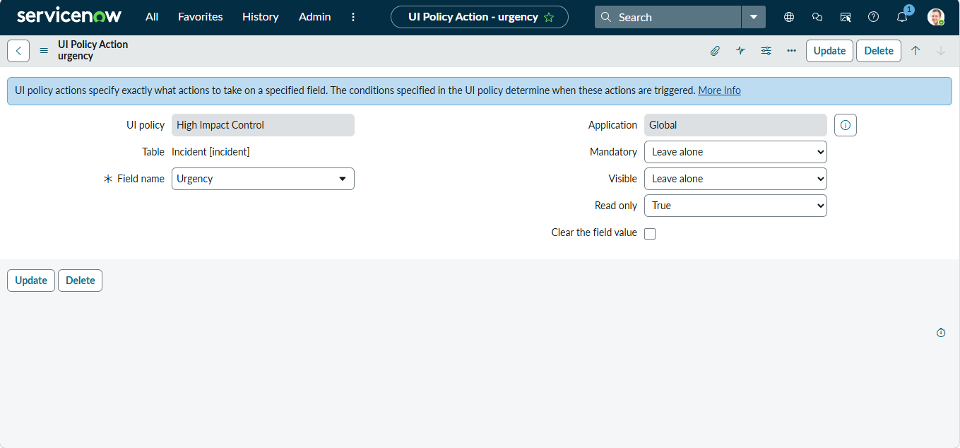

11.3 Client Script Evidence
Figure 11.3 – onChange Client Script
Shows the configuration of:
Auto set urgency for high impact
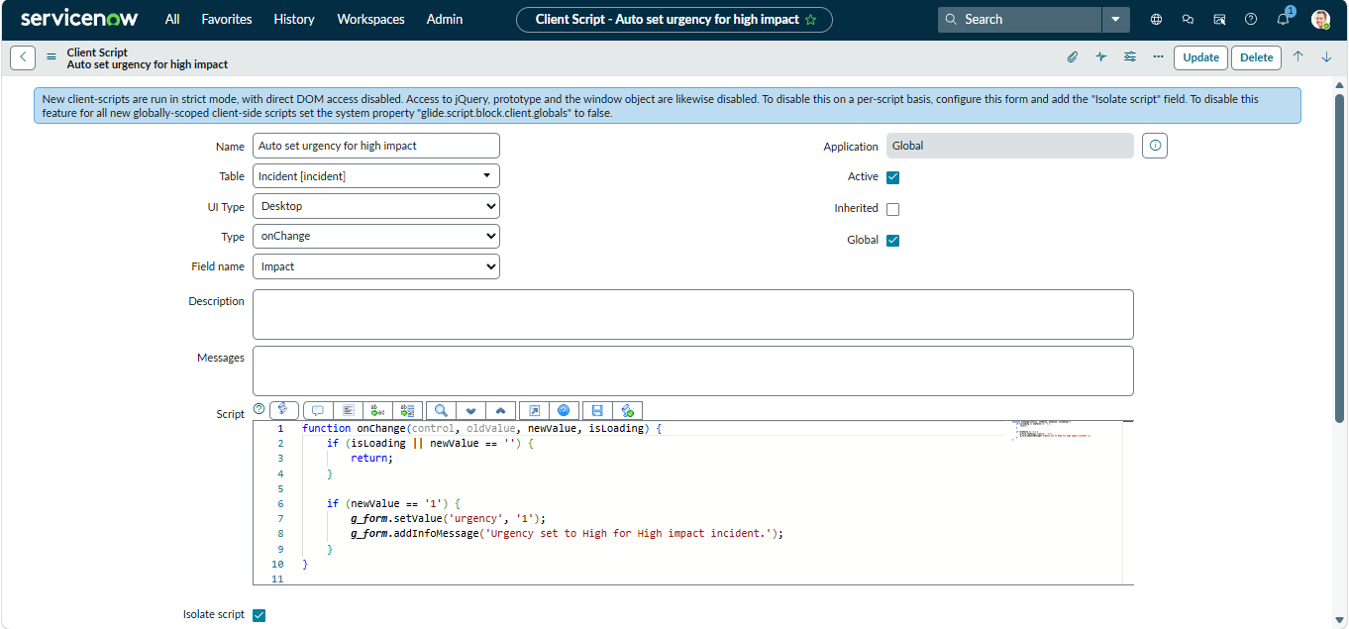

Figure 11.4 – onSubmit Client Script
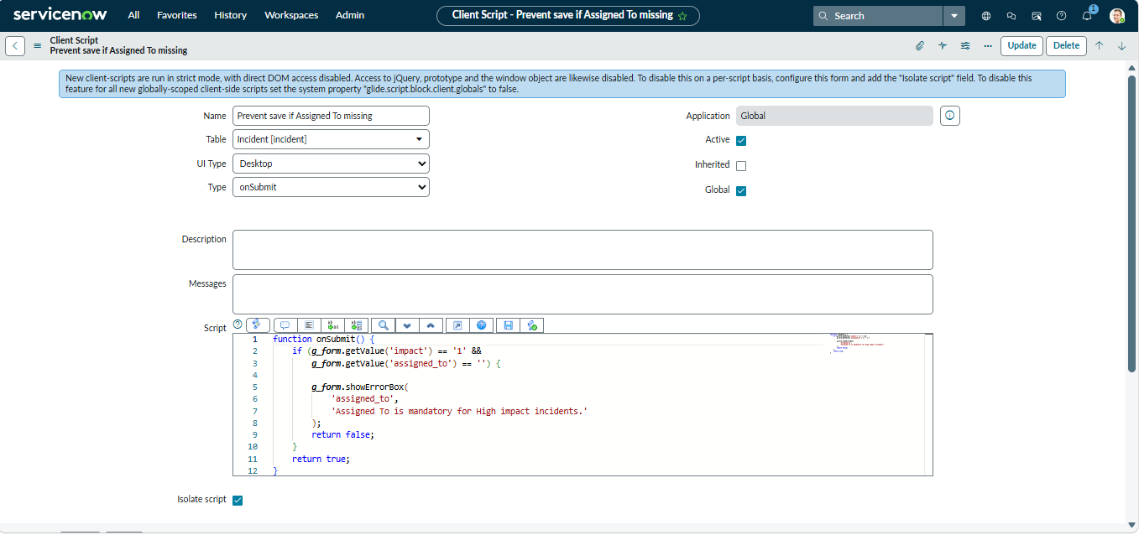

Figure 11.5 – onCellEdit Client Script
Shows the configuration of:
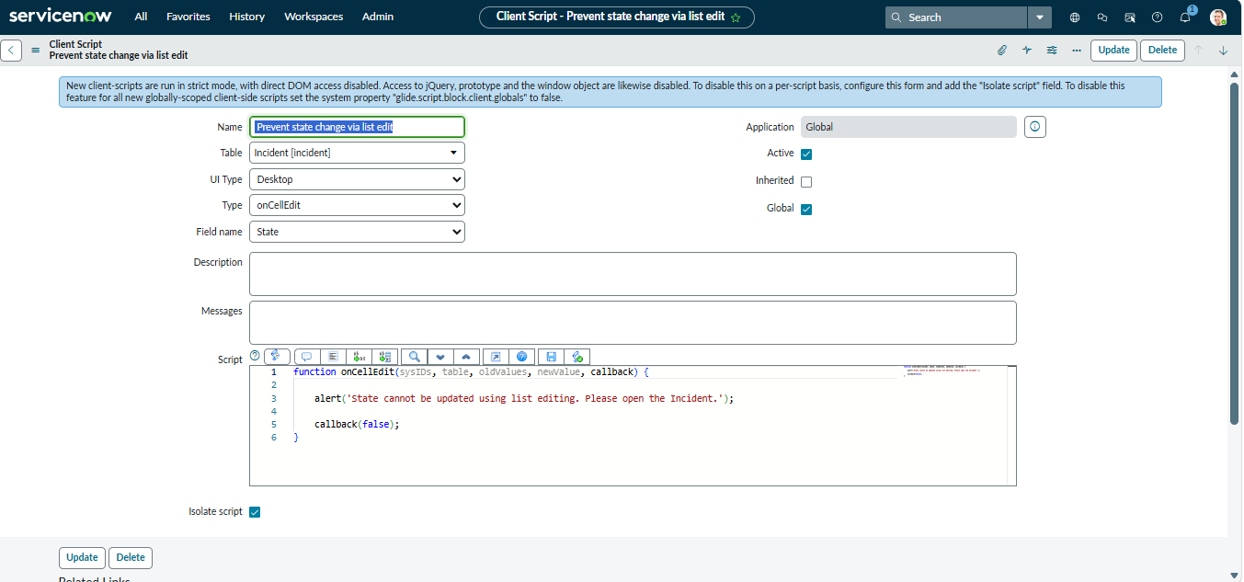
Prevent state change via list edit

11.4 Testing Evidence
Figure 11.6 – High Impact Mandatory Enforcement
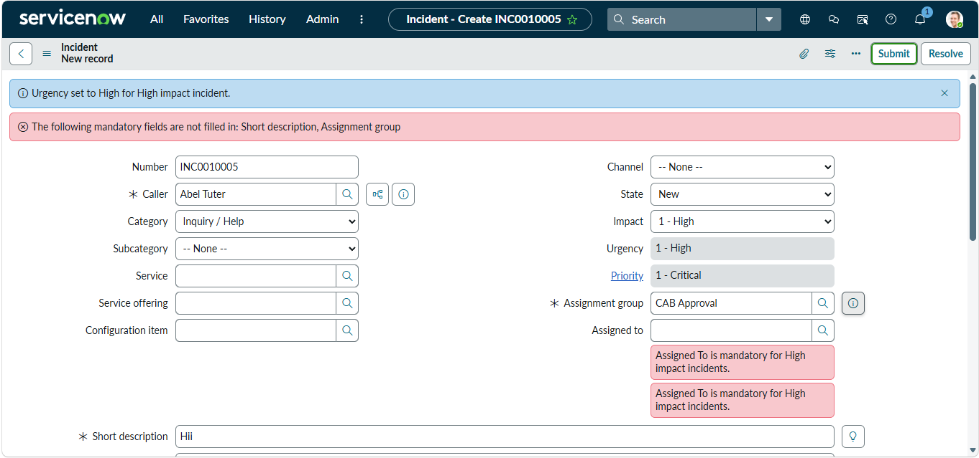
Provides evidence of the mandatory field behaviour.

Figure 11.7 – Successful Incident Save
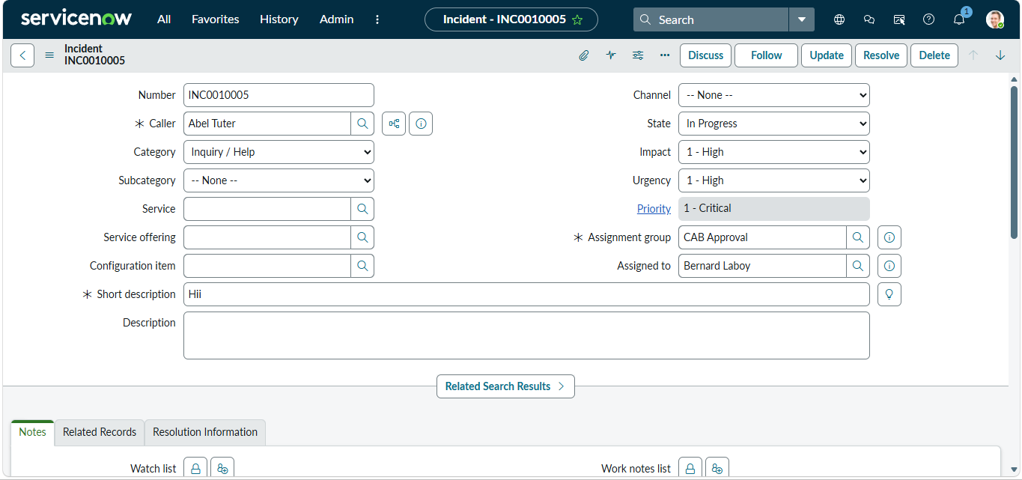
Provides evidence that the Incident can be saved when the required information is provided.

Figure 11.8 – Reverse Condition
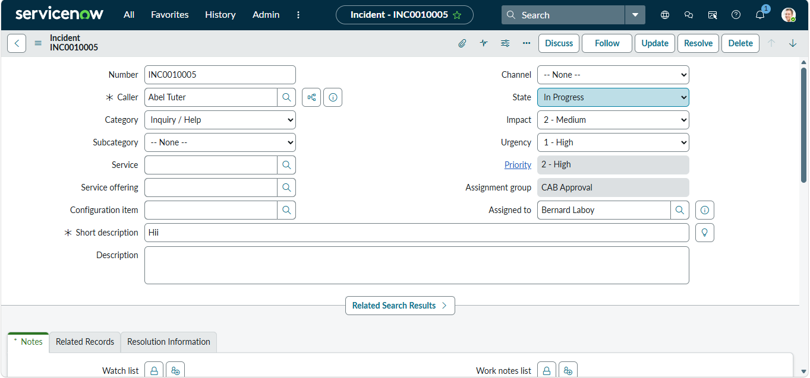
Provides evidence of the UI Policy behaviour when Impact changes from High to Medium.

Figure 11.9 – State List-Edit Blocking
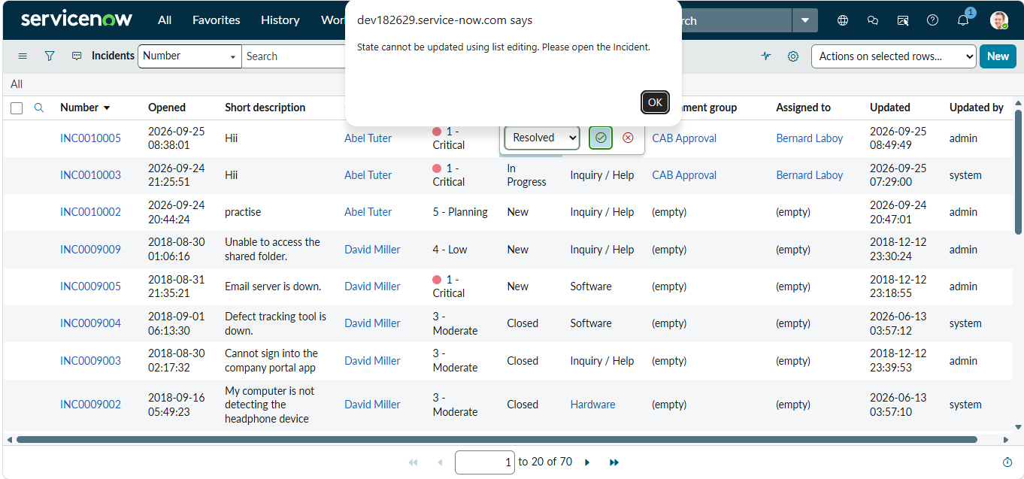
Provides evidence that direct State editing from the Incident list is prevented.

Figure 11.10 – Form-Based State Update
Provides evidence that State can still be updated through the Incident form..
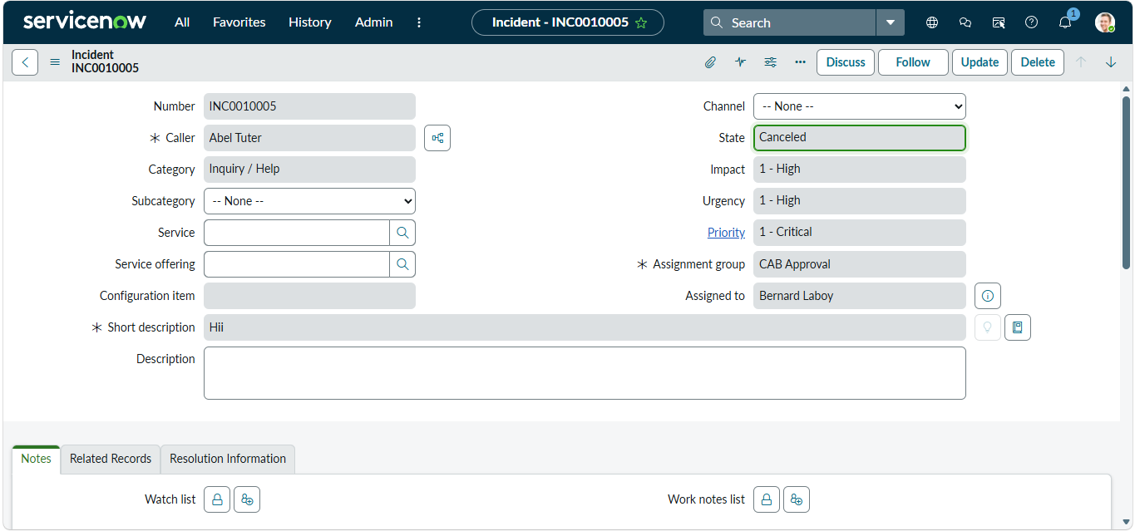

12. PROJECT OUTCOME
The project successfully demonstrates the implementation of ServiceNow UI Policies and Client Scripts for controlling Incident behaviour.
The implemented solution provides the following outcomes:
Dynamic Field Behaviour
The Incident form responds to the Impact value through the configured UI Policy.
Mandatory Field Control
Assignment Group becomes mandatory when Impact is High.
Urgency Control
The Urgency field is controlled through the UI Policy Action.
Automatic Value Update
The onChange Client Script automatically sets Urgency to High when Impact becomes High.
Submission Validation
The onSubmit Client Script prevents submission when a High Impact Incident has no Assigned To value.
List Edit Restriction
The onCellEdit Client Script prevents direct State changes from the Incident list.
Form-Based Updating
Users can still perform valid State changes through the Incident form.
Testing
The implemented configurations were tested through five functional tests covering mandatory enforcement, successful save, reverse condition, list-edit blocking, and form-based State updating.
Overall, the project demonstrates how ServiceNow configuration and scripting features can be combined to provide controlled Incident behaviour.

13. CONCLUSION
The Implement Client Script & UI Policy (Incident) project demonstrates the practical implementation of ServiceNow UI Policies, UI Policy Actions, and Client Scripts within the Incident Management environment.
The project uses the High Impact Control UI Policy to control Incident fields when Impact is High. The Assignment Group field becomes mandatory, while the Urgency field is controlled through the associated UI Policy Action.
The Auto set urgency for high impact onChange Client Script provides automatic Urgency updates when the Impact field changes.
The Prevent save if Assigned To missing onSubmit Client Script provides submission validation by preventing High Impact Incidents from being submitted without an Assigned To value.
The Prevent state change via list edit onCellEdit Client Script prevents direct State changes through the Incident list while allowing valid State updates through the Incident form.
The project was tested using five functional tests covering mandatory enforcement, successful Incident saving, reverse condition behaviour, State list-edit blocking, and form-based State updating.
The completed project provides a practical demonstration of how ServiceNow configuration and client-side scripting can be used to control Incident form behaviour, validate user input, automate field updates, and restrict unwanted list-based modifications.
The project documentation, phase documents, testing evidence, screenshots, and Client Script source files together provide the supporting material for the completed implementation.

